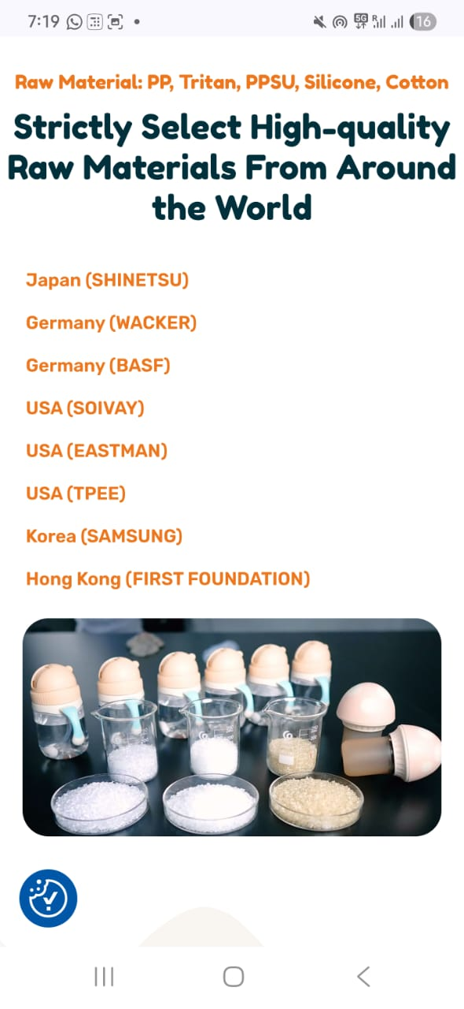

Reliance India

Ruco Inks Germany

Marabu Inks Germany